Dear Exxon Mobil:

The Society of Women Engineers (SWE) is the driving force that establishes engineering as a highly desirable career for women through an exciting array of training and development programs, networking opportunities, scholarships, outreach and advocacy activities, and much more.

We invite you to be a part of the Dallas Society of Women Engineers and help support our organization & members in our mission of empowering professional engineers to succeed and advance in engineering as well as guiding girls towards careers in Science, Technology, Engineering and Math (STEM)! Studies show that early influences make an enormous impression on girls. Our goal is to help shape an academic interest in STEM disciplines in high school and college, leading to careers in these fields. Your support will help guide young women in viewing engineering and science as a life-long passion.

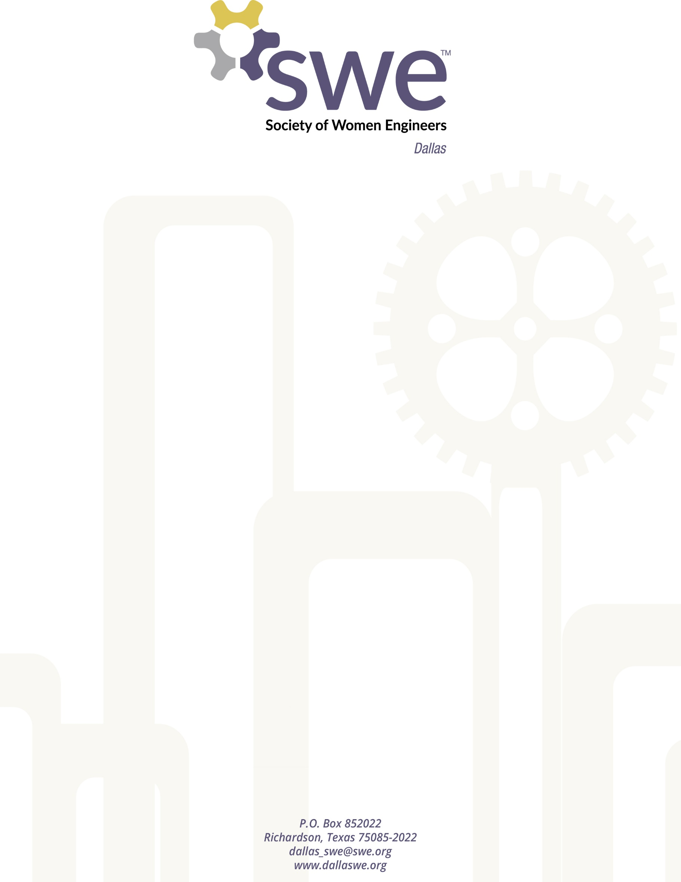
We need your help to enable Dallas SWE's signature outreach event series, Design Your World – STEM Conference for Girls (DYW) that is run twice a year impacting 1200 girls from 4-12th grade to date. In 2013 we made an effort to run parallel sessions for parents and educators. This was recognized nationally with the SWE award for parent/educator outreach. In 2014-2015 we made a concerted effort to increase the traditionally underrepresented minority participation (URM). Of the 280 girls we hosted at UT Dallas and in Zan Wesley Holmes Jr. Middle School, at least 70% were URM. The parent and educator sessions were recognized by SWE a second time with their parent/educator outreach award. In 2015-2016, the events held at Southern Methodist University and the University of North Texas reached 300 girls and over 150 parents and educators. Over 160 volunteers committed 600 hours to make an enormous impact on girls. This targeted all day effort is supplemented with our individual outreach in schools, Perot Museum, Frontiers of Flight Museum which has reached 2500 boys and girls over the last year.

The next Design Your World STEM Conference will be held in early November 2017 (exact date and location to be provided soon). Collegiate and professional engineers are signed up to volunteer having experienced the rewards that come from inspiring the future. Your funds enable us to give lunch, a t-shirt, and purchase activity supplies for students to do three engineering design projects.

Having your company represented on our sponsorship materials, keynote speaker sessions, individual activity sessions, lunch, and registration areas is vital to communicate to girls and their parents that there is a enormous amount of opportunity for those who utilize their potential to be STEM professionals. Sponsorship offers your company the opportunity to be recognized by the large community of professionals, parents, teachers, and volunteers, as you support women, both young and old, in exploring science, engineering, and math as future careers. Please consider supporting our outreach activity as well as our scholarship and professional networking events. To allow us to budget our Fall activity, please provide us support by October 2, 2017.

Respectfully,

Liz Hainey
Treasurer
Dallas Society of Women Engineers
2017-2018
(214) 533-2401 (Cell)

FY 2017 Dallas Society of Women Engineers - Sponsor Commitment Form

- Outreach: Design Your World - STEM Conference for Girls: (select one below - put an X in the left column)

Sponsorship will cover recognition for BOTH DYW events over 2017-2018
Platinum sponsors will be recognized at DYW, high school engineering fairs and other events where we participate impacting 2500 girls and boys annually.

 | Design Your World  Contribution Levels |  | Company Logo Placement | Exhibitor Table | Media Recognition | Speaking Engagements
 | Platinum Sponsor | $5,000+ | Website homepage T-shirts, Opening Session | Prime Location | Prime | Opening or Closing Ceremony*
 | Gold Sponsor | $2500-4999 | Website & T-shirts | Guaranteed | Some | Breakout Session*
 | Silver Sponsor | $1000-2499 | Website | If Available* | - | -
 | Bronze Sponsor | $500-1000 | Website | - | - | -
*Limited Availability, contact us for more information

- Section Sponsorship Opportunities/Levels (please select one or more – put an X in the left column)

Note: All donations include advertisement on the Dallas SWE website:
Company Name $100-499, Company Logo $500-1999, Homepage Company Logo $2000+

 | Sponsorship Types |  | Amount | Description
 | Named Scholarship | $500-$10,000 | $______ | Contribute to inspiring the next generation of engineers by donating a signature scholarship that will bear the donor’s name. Please contact us for more information.
 | Scholarship Fund | $100+ | $______ | Inspire the next generation of engineers by contributing to our scholarship fund. The donor’s name and/or company logo will be listed on the Dallas SWE website for one year.
 | Professional Development | $500 | $500 | Host a Dallas SWE professional development event at a venue of your choice. Limited availability, and will have to coordinate with Dallas SWE leadership on scheduling & topic.
 | Collegiate and Community College Student  Mentorship Fund | $500 | $500 | Donate to help Dallas SWE support the SMU, UTD, or Collin College SWE student sections. Funds will be distributed at the executive council’s discretion to either section for scholarships, joint-events, mentoring program, etc.
 | General Donation | $100+ | $______ | For support of the annual Dallas SWE operating expenses including: scholarships, awards, community outreach, leadership retreats, conference attendance, office supplies, and more!

Signature: __________________________________________ Date: __________________________
Contact Name: Please return to:
dallas.swe@gmail.com
Company & Title: Or mail to:
Dallas Society of Women Engineers
Mailing address: P.O. Box 852022
Richardson, Texas 75085-2022
Phone: -------------------------------------------
Contact us:
Fax: www.dallaswe.org or
www.designyourworld.org
E-mail address: dallas.swe@gmail.com

