Renew Your Membership!

Fellow SWEsters, it’s that time again! Membership renewals are in full swing! If you renew your membership before June 30th, you will be entered into a drawing to win a $100 Amazon gift card! Please see below for directions to renew via the new SWE website.

- Navigate to https://swe.org/
- Scroll down, and click on "Membership"

- Enter your username and password.
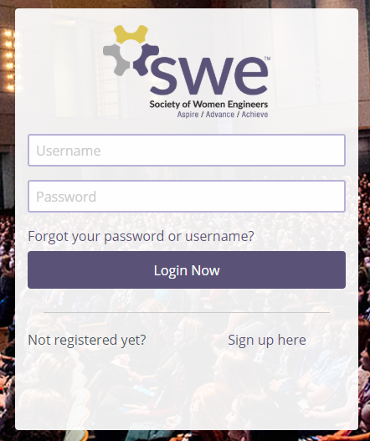

- Once logged in, you will be taken to the SWE Account Portal. Click on "SWE Membership Renewal."
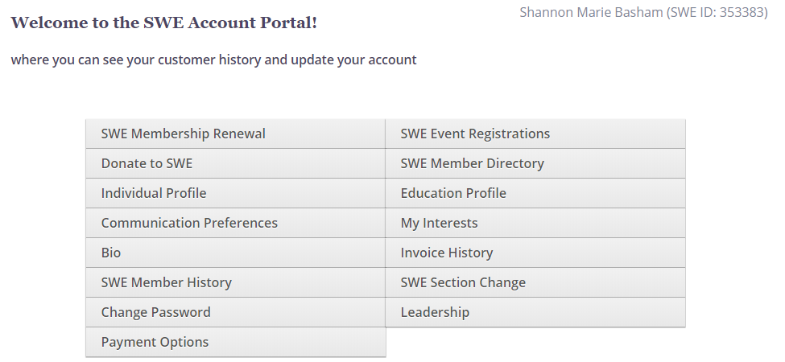

- You will be taken to the Membership Renewal Portal. It will default to your last Membership Level. If that has not changed, you can move to the next step; otherwise, select your Membership Level (Professional, Student, etc.).
- Click on "Add to Cart."
- Enter your payment information, and click on the "Submit" button.
- You're all set! You will receive an email from SWE with your receipt.

Welcome back! We are happy to have you as a member of the Society of Women Engineers!

